**Hudson Furnishing’s**

|  |  |  |
| --- | --- | --- |
| Supervisor: | Sir Salman | |
| Batch: | 2206F | |
| Group: | Hudson Furnishings | |
| Serial No. | Enrollment No. | Student Name. |
| 1. | 1396147 | Mashkoor Ahmed |
| 2. | 1386957 | Muhammad Hassan |
| 3. | 1386760 | Abdul Samad |
| 4. | 1387224 | Hasnain Jamil |

**Acknowledgement**

*The first, we would like to express my special thanks of gratitude to my teacher SIR ZAMAN who helped a lot in finalizing this project within the limited time frame, valuable counseling and assistance for the accomplishment of this project.*

*Secondly, we would also like to thanks the e-project team at Aptech Head Office, who gave as the opportunity to do this interesting and wonderful project about Hudson furnishings*

*Thirdly, we also thank the e-project team for giving this task to us. Following are the benefits of this Project:*

* *Re-enforcement of skills happens in the experimental learning process.*
* *A mentor, ensuring that we do not get drifted, constantly guide us.*
* *It gives us a lot of confidence to face an interview as we have worked on a project. We can explain virtually everything on the subject we have learnt.*

**Synopsis**

* Hudson furnishings is a very important feature used in e-commerce to assist people making purchases online, similar to the US English term ‘ordering cart’. The business to customer aspect of furniture store (e-commerce) is the most visible business use the World Wide Web. The synopsis of online Hudson furnishings to develop a general-purpose e-commerce store where any furnishing items (chair, bed, sofa, cupboard, chest, cabinates,dining tables etc.). can be bought for the comfort of home. In order to facilities

Online purchase a ordering cart is provided to the user. These include 3-architecture, server, and client-side scripting techniques implementation technologies such as ASP.NET, programming language (such as C#), relational database (such as SQL server).

The Hudson furnishings is a virtual store on the internet where customer can browse the catalogue and select products of interest. The selected item may be collected in a ordering cart. At checkout time the item in the ordering cart will be represented and order.

. The synopsis of online furnishing store is to develop a general-purpose e-commerce store where any furnishing item (such as chair, bed, cabinets, cupboard, sofa,chests,dinningtables etc.) can be bought for the comfort of home. It provides the user with a catalogue of different type of ice-creams available for purchase in the store. This project has been developed to allow business grow larger and faster.

Customer is the user of the system. An Administrator the website is the super user. When the user type in the URL of the website, a home page shown.

The user will go to the About, Contact, Service, Login and Registration page from the home page.

*Problems Definition*

*Mr. “Mashkoor Ahmed” is the owner of the big Furnishing shop. He is famous for the unique design and quality of the product they provide. As the number of Customer is increasing day by day, the branches of the store keeps On increasing. To popularize it more the owner of the company has decided to go for making the website of his store. For this he has Approached you to make the website.*

*Customer Requirement Specification (CRS)*

*To popularize his furnishing store, Mr. “Mashkoor Ahmed” has listed out the few*

*points which he wants to be there in website.*

*Here is list to be design in the project*

*1) Home page: should contain Menus like home, About US, Shop*

*, Contact Us*

* *For Register page the customer can register with the*

*Site provided he/she makes the payment*

*Once the users get registered he/she must be allowed to*

*Login with their user name and password.*

*2) Feedback form (to take the feedback from both registered*

*users and Unregistered Users.*

*3) About Us: Describe about the Hudson Furnishings and the owner.*

*4) Contact Us: Should display the Contact details*

*For the entire list mentioned below the steps of making must*

*be added by the admin through ADMIN Login. An image*

*must be added for each product of furniture.*

* *Chairs*
* *Tables*
* *Chests*
* *Sofa*
* *Cupboards*
* *Dinning Tables*
* *Beds*
* *Cabinets*
* *Details of the furniture’s items will be added and updated.*
* *Checking the List of the registered users and their*

*payment details.*

*Scope of The Work (Briefly)*

*The name of the project is Hudson Furnishings the software provides the customer various facilities .in this project we can easily maintain Hudson Furnishings sales details.*

*It’s gives complete information of Furnishing store its name, price, and category etc. we can see the furniture’s details before purchasing the particular furniture and view for our requirements satisfying item detail.*

*Hudson Furnishing automation system provides ability to view any Furniture of different category available in the shop. Admin can perform login by entering Username and Password and register to purchasing. Users allotted to him and can view the feedback submitted by Users. That means a she which has the system which provides the facility to the customer of the shop to purchase the furniture from the store without any difficulty and complexity.*

*For example, any customer wants to purchase any furniture from the store than first customer has to login in the website and then just choose the category of the furniture products than he/she can see the more than one type of furniture’s there and then he/she can choose the specific furniture from there.*

***Sitemap***

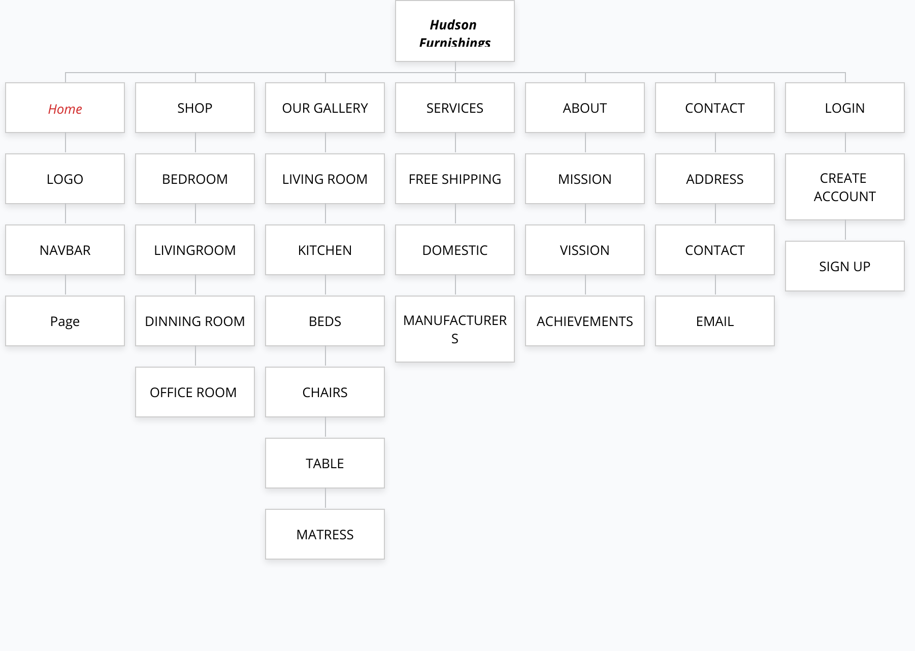

***Wireframes***

***Hudson’s Furnishings Home Shop Features Service About Contact***

Layout

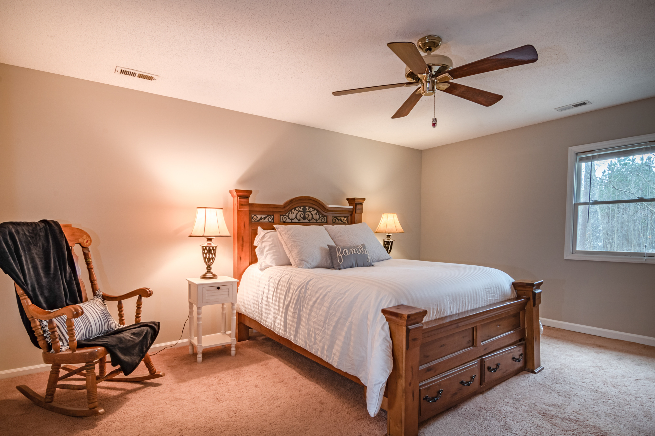

Bottom Layout

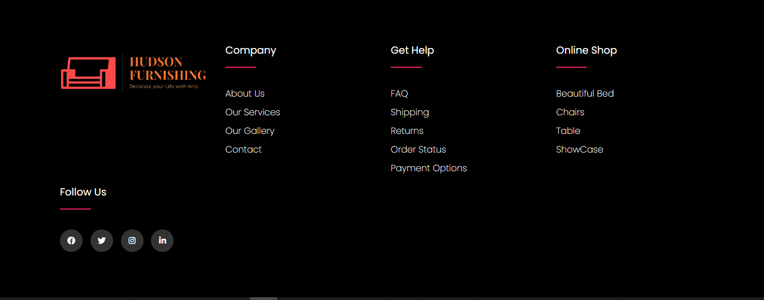

***Home Page***

Our Specialties

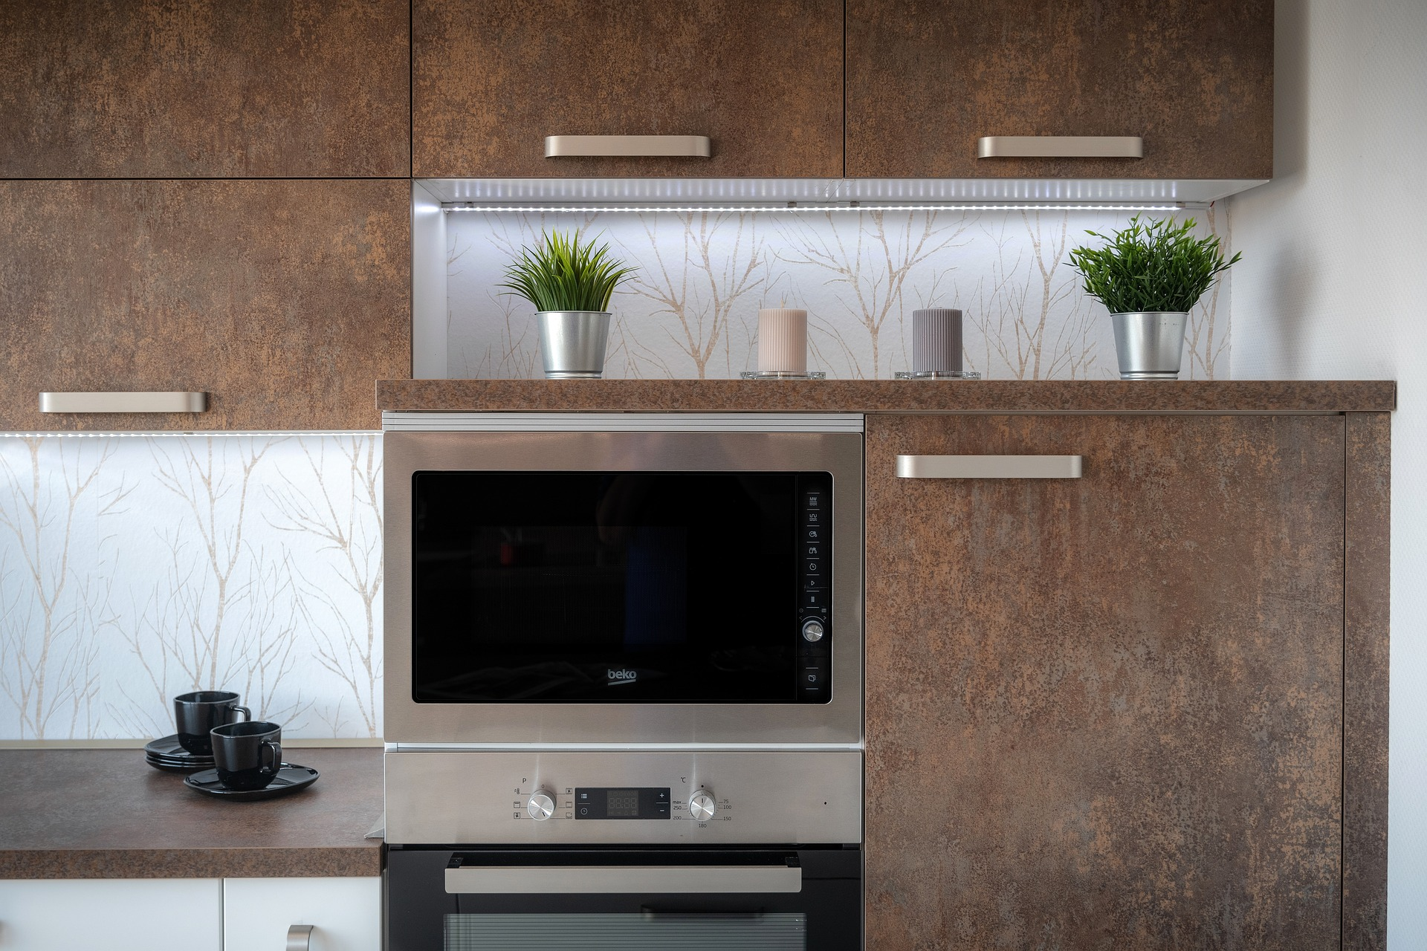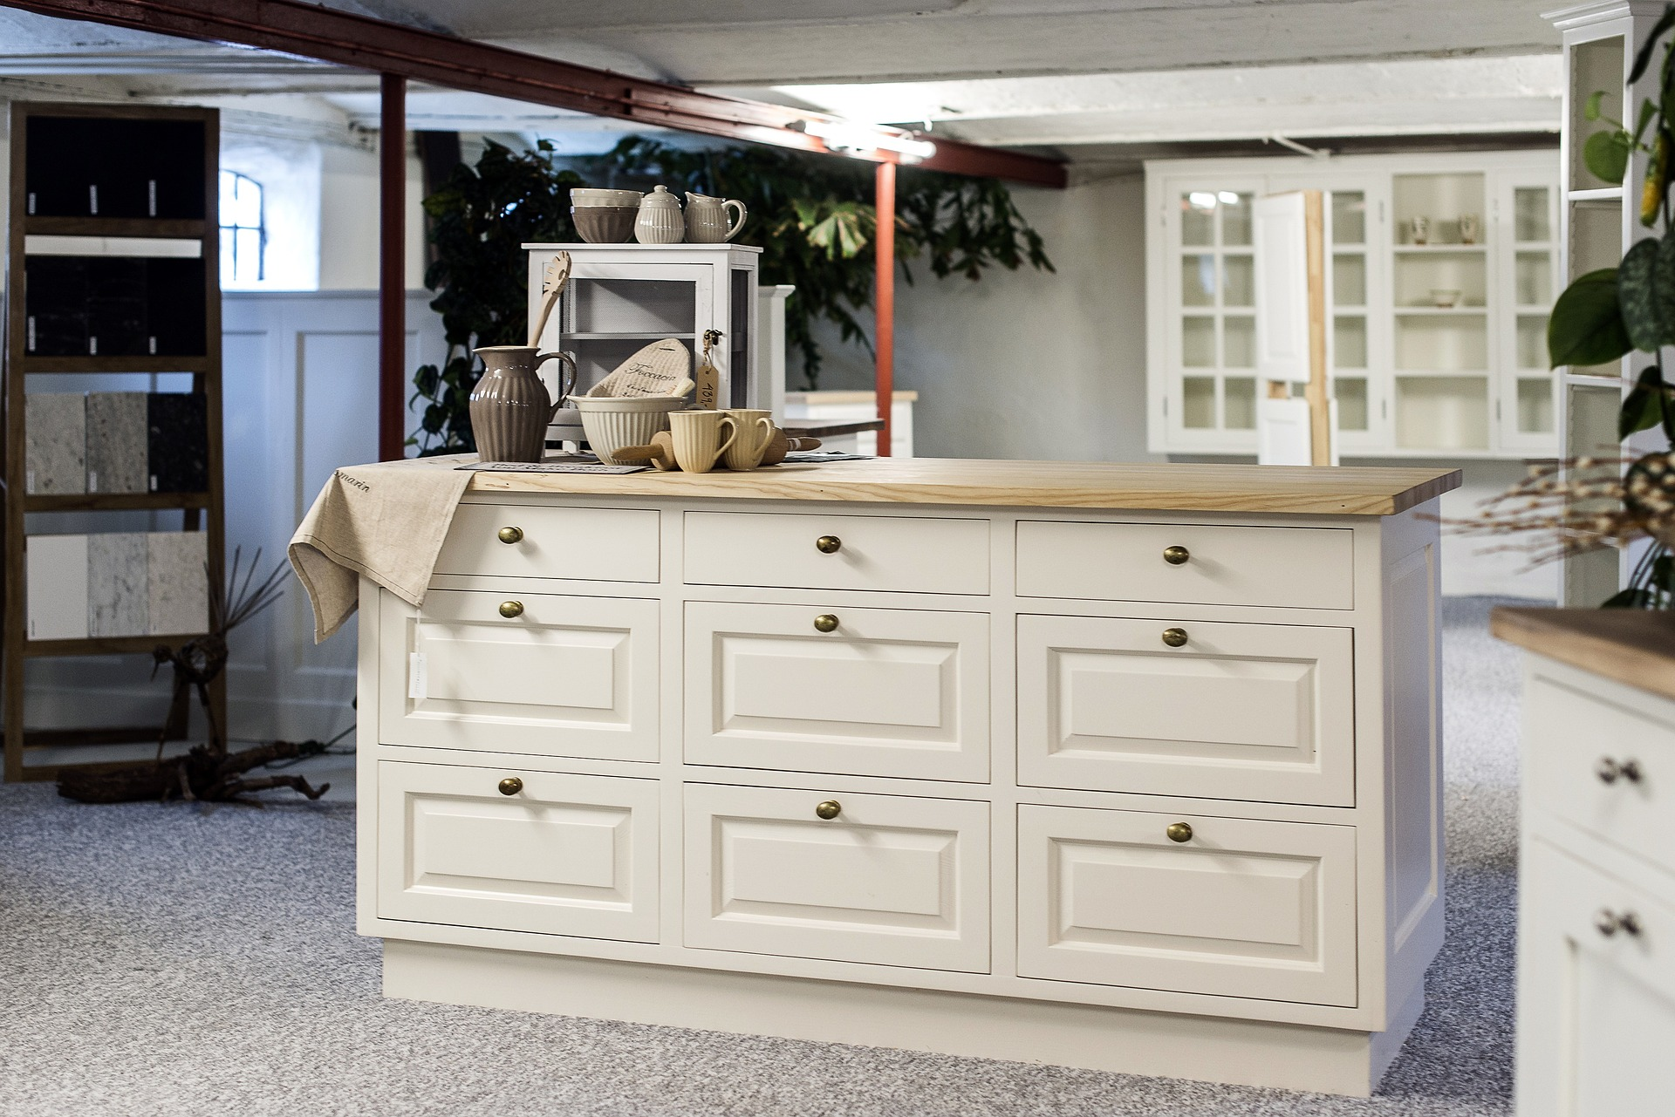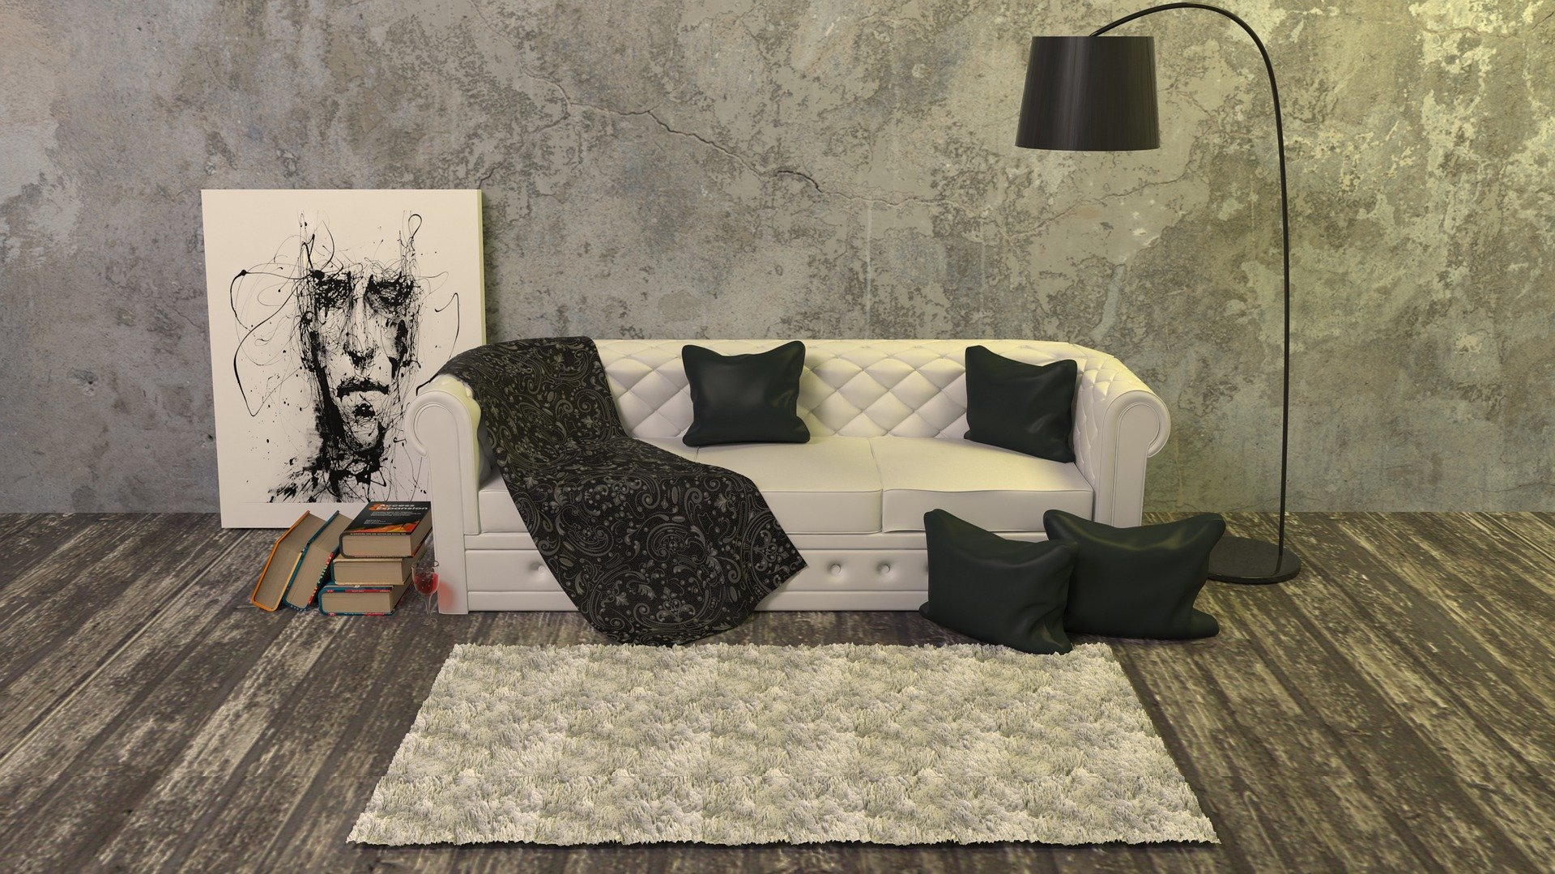

Our Designs

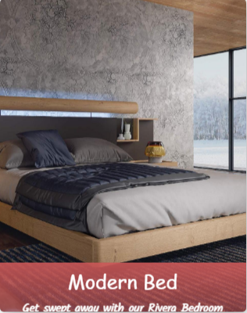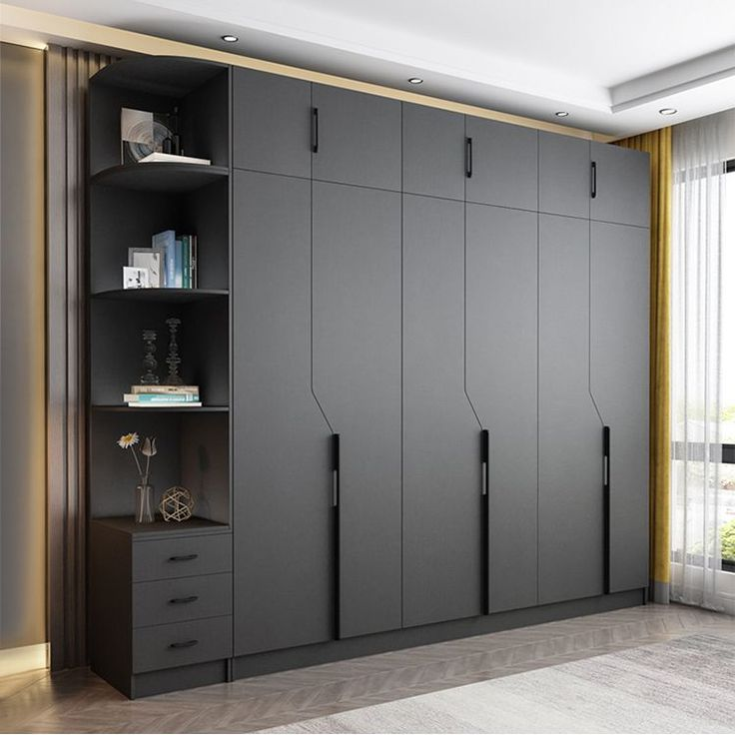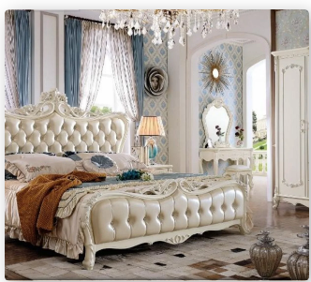

***Image***

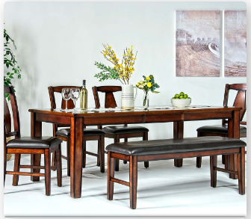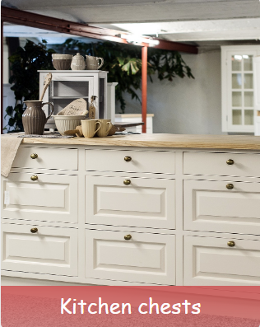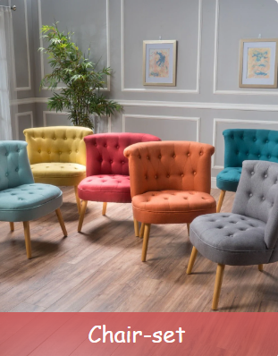

Designs & Price’s

***Costumer Review’s***

***Shop Page***

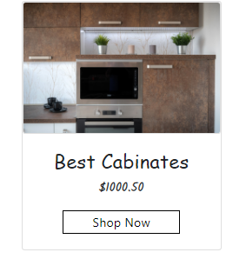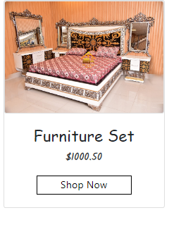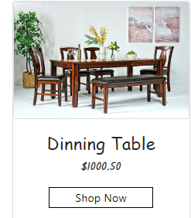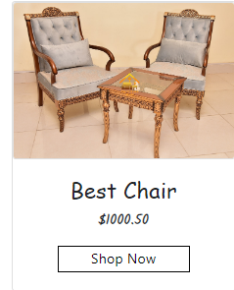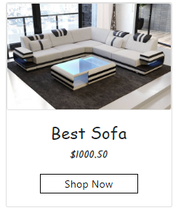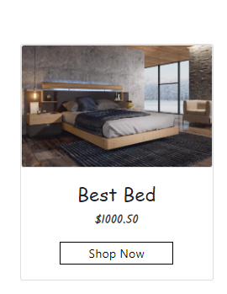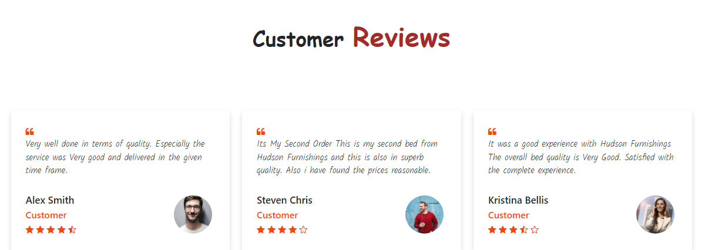

***About Us***

***About Page***

We Believe in innovating the entire furniture industry and we think we have done good so far, Allhamdullilah However, there is a long way to go and we are right on track, insha’Allah what comes next will be even better along the journey.

“Something for everyone” is that we work for. And this single motto enables us to provide a huge range of furniture that fulfills your needs. At the same time, “quality” is our slogan. We are here to rule and to rule means: we are here to provide the best furniture at the best possible price. Love us and we don’t ditch you!

***Login/Register page***

***Login/Register page***

***Login Register***

***ENTER FIRST NAME***

***Enter your Email***

***Login***

***ENTER ADDRESS***

***CONFIRM YOUR PASSWORD***

***ENTER PASSWORD***

***ENTER PHONE NUMBER***

***CONFIRM YOUR EMAIL***

***ENTER NAME***

***ENTER LAST NAME***

***Enter your Password***

Show Password

***ZIPCODE***

***ENTER LOCALITY***

***BLOCK OR UNIT***

***ENTER YOUR CITY***

***ENTER YOUR COUNTRY***

I accept all Terms & Conditions

SUBMIT

***Task Sheet***

|  |  |  |  |  |  |  |
| --- | --- | --- | --- | --- | --- | --- |
| Project Ref.No:  Ep/Advertisement  Portal Management  System /01 | | Project  Title | Date of preparation of Activity Plan | | | |
| No. | ***Task*** | HUDSON-FURNISHINGS | ***Actual***  ***Start Date*** | ***Actual Days*** | ***Team-Mate***  ***Name*** | ***Status*** |
| 01. | ***Home page*** | 8  -  O  C  T  -  2  0  2  2 | 3  0  -  D  A  Y  S | Mashkoor Ahmed |  |
| 02. | ***Shop page*** | Abdul Samad |  |
| 03. | ***About page*** | Hasnain Jamil |  |
| 04. | ***Contact page*** | Muhammad Hassan |  |
| 05. | ***Login/ Register page*** | Muhammad Hassan |  |
| 06. | ***Documentation*** | All |  |